width: 2,352 m

Calculation:

Task:
Calculate how many Euro-pallets-pitches one 40-feet-maritime container has and sketch them
in the plan below.
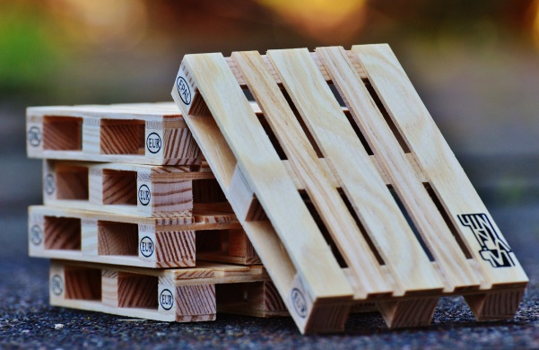  Von Mdornseif - Eigenes Werk, GFDL, https://commons.wikimedia.org/w/index.php?curid=3489261 | 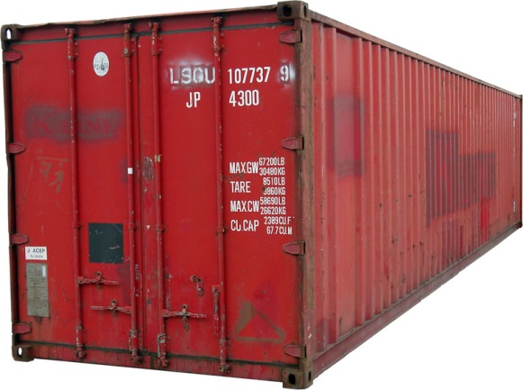  Von KMJ CC BY-SA 3.0, https://commons.wikimedia.org/w/index.php?curid=1443327
euro-pallet  dimension: 120 x 80 x 14,4 cm | 40-feet-maritime container  internal dimension: 12,03 x 2,35 x 2,38 m

Sketch:

scale: 1:33 1/3 length: 12,032 m

