Climate change detectives

Required materials
Printed photos – see below
Coloured markers or pens
Large sheets of paper or whiteboard

Learning objectives
- Students recognise visual signs and impacts of climate change.
- Students identify links between global environmental changes and climate changes.
- Students exchange views on personal perceptions and global perspectives.
- Students develop an initial awareness of the urgency of climate-related challenges.
Difficulty

Curriculum alignment
- Geography
- Education for sustainable development
- Climate change

Target groups
- Lower secondary level

Duration
1 lesson
Type of activity
Small group work (3–5 people)

40

Climate change detectives

Task description: The task is to find out what climate change is, who it affects and how it affects us.
40
Cards with impacts: Each group receives an image showing different impacts of climate change.
Group discussion: The groups discuss what can be seen in the images and how these impacts are related to climate change. They also consider which regions and people are particularly affected. How can we experience climate change ourselves?
Presenting results: Each group presents its findings and sticks the images onto a large sheet of paper or the whiteboard. The ideas are supplemented by guiding questions on the poster, for example: Who is most affected by these impacts of climate change? Why do these impacts occur? What measures can be taken?
Joint reflection: The results are discussed with the class. What have students learned about climate change? Which impact stood out to them in particular? How can we experience climate change ourselves?
The images showing the consequences of global warming (see below) can also be discussed here.

Image sources: Pixabay

© Pixabay

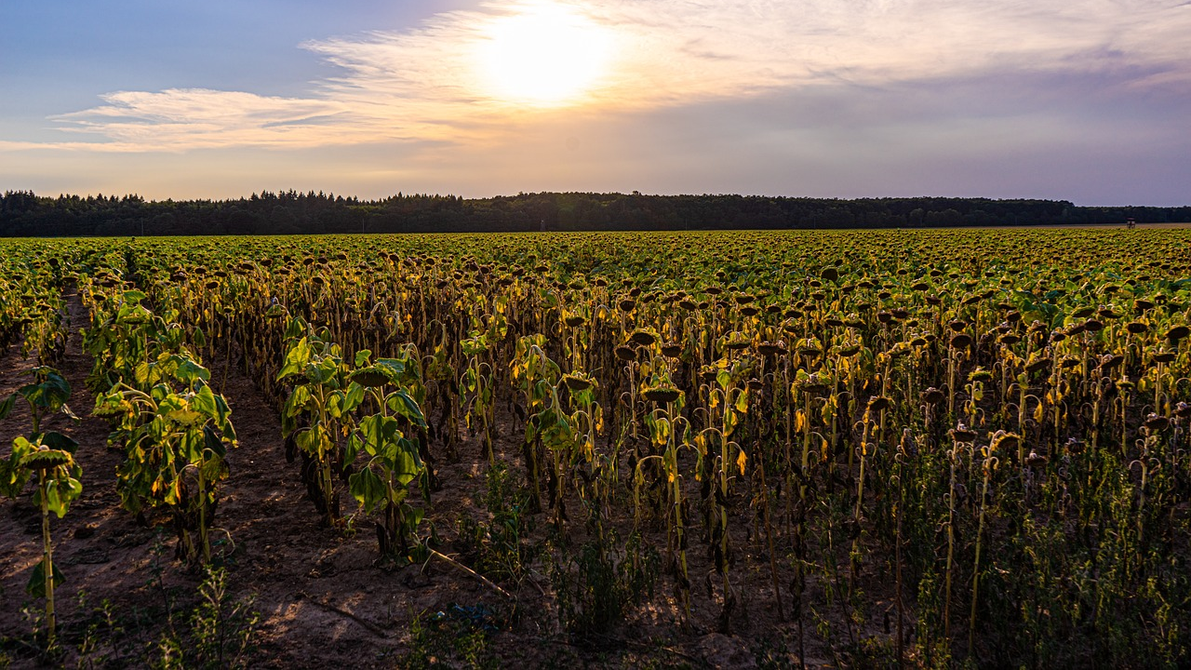
© Pixabay

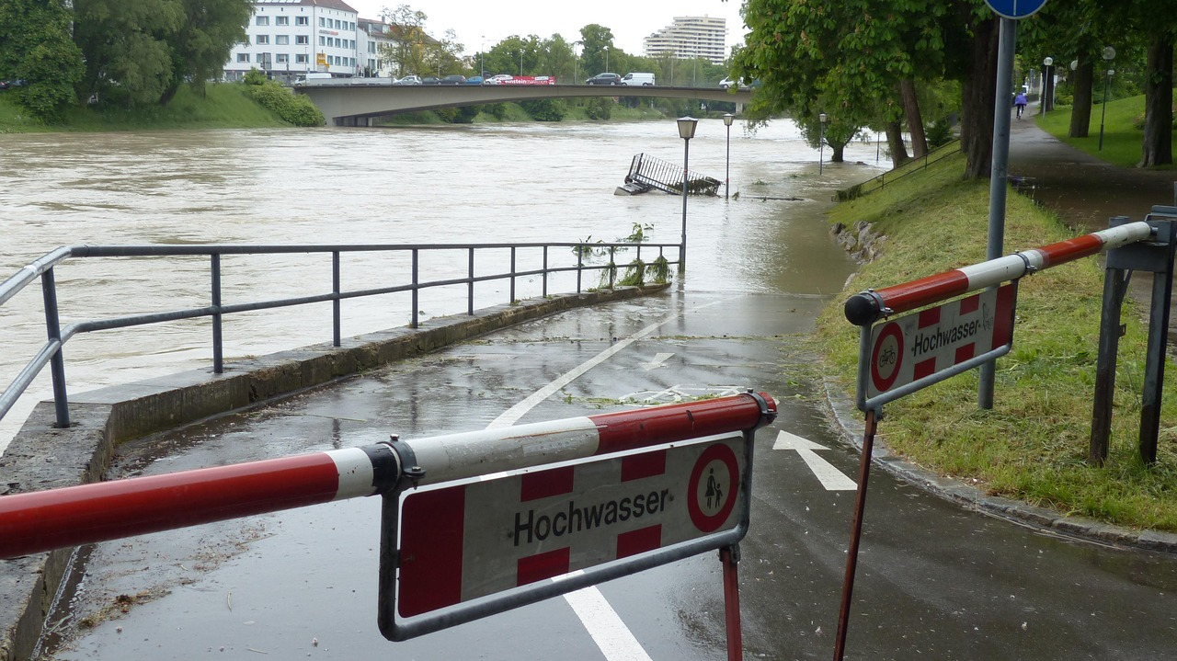
© Pixabay

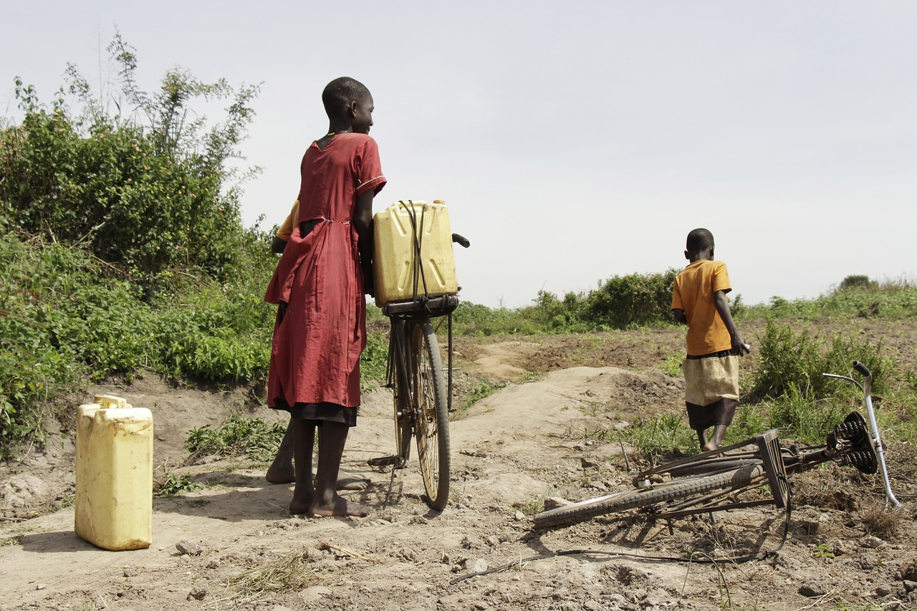
© Pixabay

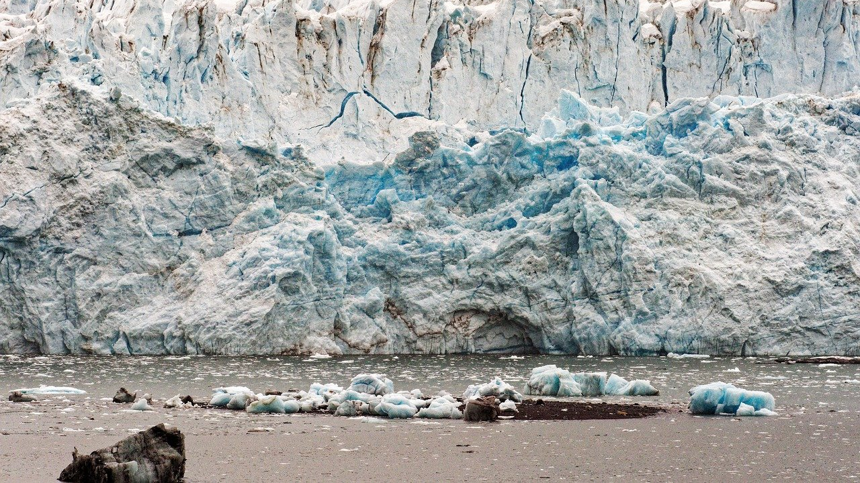
© Pixabay
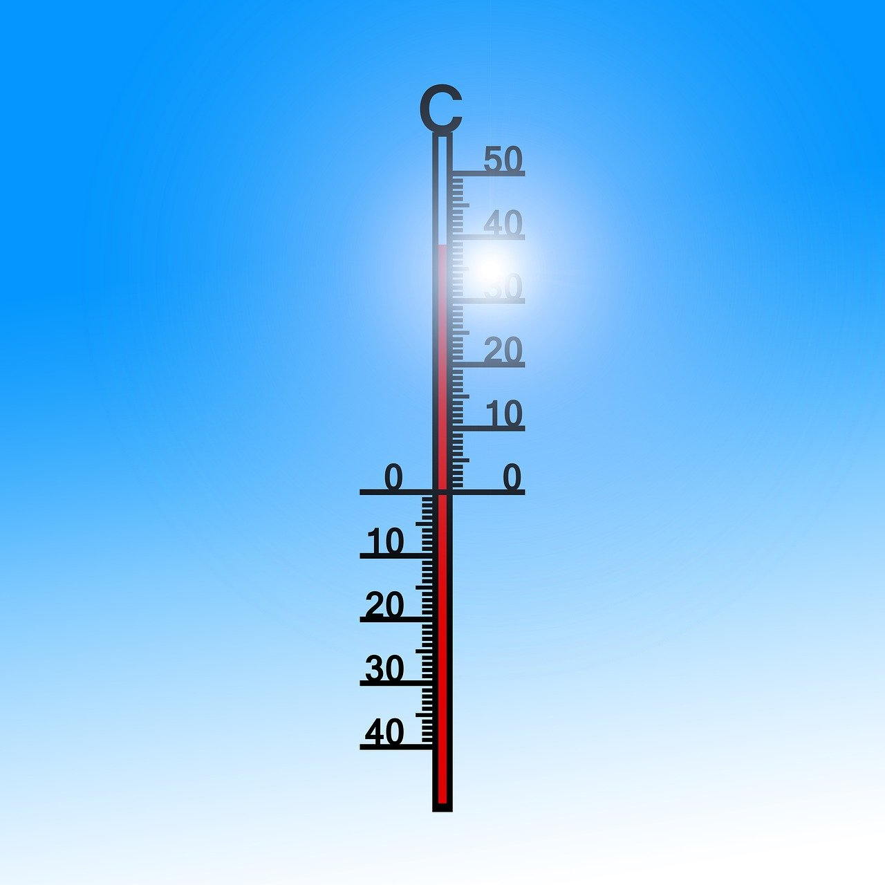
© Pixabay

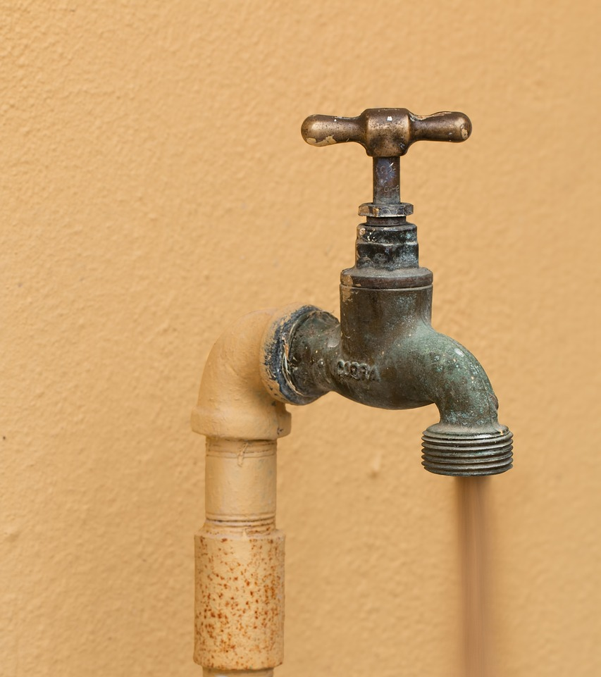
© Pixabay

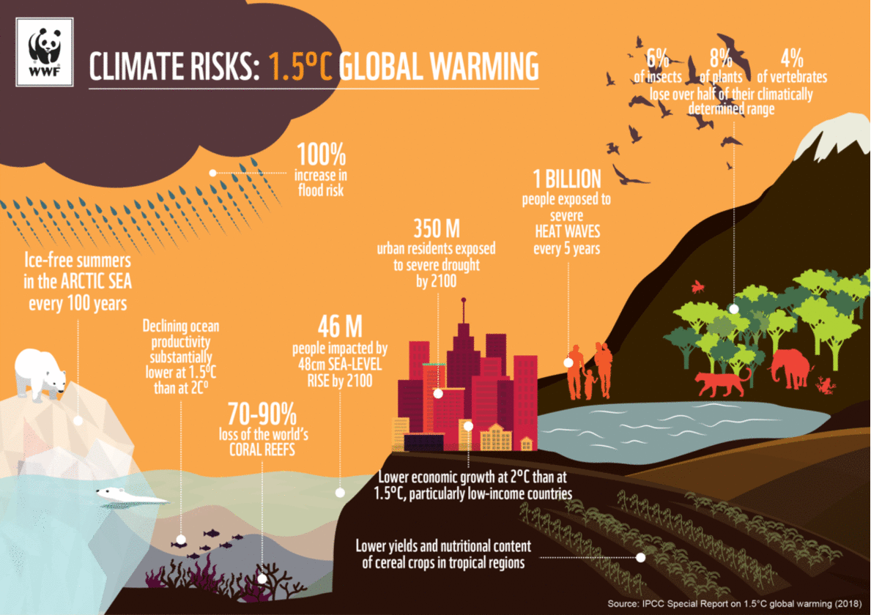
Video source: WWF UK – Link: https://www.wwf.org.uk/updates/climate-change-melting-away-community

Sources:
European Commission (2024): https://climate.ec.europa.eu/climate-change/causes-climate-change_de ; accessed 15.05.2024
IPCC (2023): https://www.de-ipcc.de/media/content/IPCC_AR6_SYR_DE_barrierefei.pdf , accessed 16.05.2024

