Load planning – container loading
Tips for teachers
Briefly review the dimensions of euro pallets and 40-foot containers in advance.
First calculate, then draw.
Point out the realistic orientation of the pallets (lengthwise/crosswise).

Learning objectives
- Students can calculate the number of euro-pallet storage positions in a 40-foot container.
- Students can correctly apply the dimensions of containers and euro pallets.
- Students can represent a loading plan graphically and draw it in a clear and comprehensible way.

Duration
15–30 minutes (also suitable as homework)
Type of exercise
Individual or pair work

40

Target groups
- Upper secondary level II
- Vocational schools
Link to curriculum
- Business administration
- Logistics

Difficulty

Load planning – container loading

Additional calculation:

Task:
40
Calculate how many euro-pallet positions fit into a 40-foot container and draw them in the
container sketch!
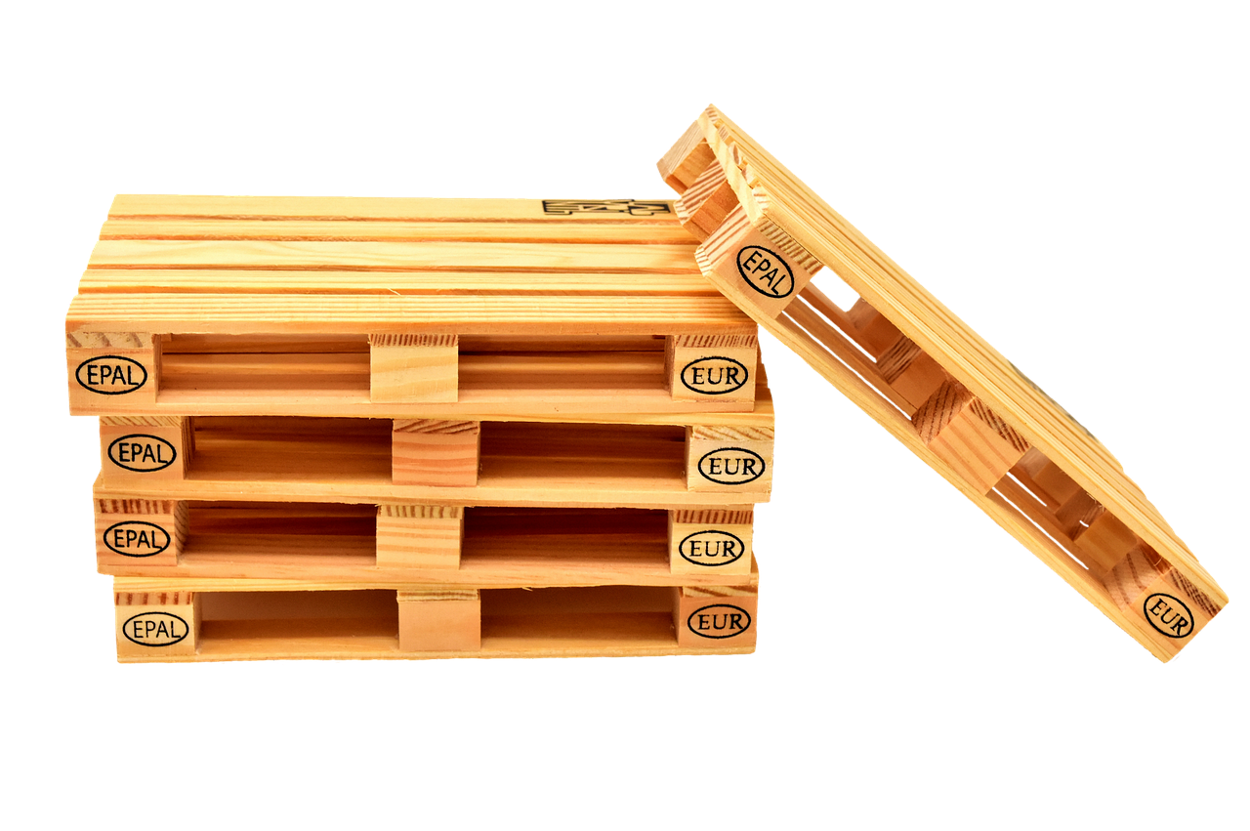  Source: pixabay, Alexas_Fotos | 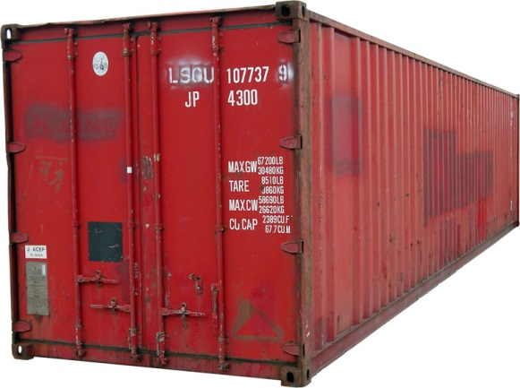  From KMJ CC BY-SA 3.0, https://commons.wikimedia.org/w/index.php?curid=1443327
Euro pallet  Dimensions: 120 x 80 x 14,4 cm | 40-foot sea freight container (MAERSK)  Internal dimensions: 12,03 x 2,35 x 2,38 m

Container sketch:

Original width: 2,352 m m

Scale: 1:33 1/3 Original length: 12,032 m

