Travelling by inland waterway – journey time calculator

Handout for lessons:
The worksheet on the following page is suitable for printing as a handout for lessons.

Learning objectives
- Students can use a journey time calculator to plan a shipping route and determine key data.
- Students can identify journey time, distance, number of locks, and transport capacity in inland waterway transport.
- Students can explain the importance of inland waterway transport for trade and the environment.
Link to curriculum
- Geography
- Business subjects

Target groups
- Upper secondary level II
- Vocational schools

Type of exercise
Individual or pair work

Duration
10–20 minutes (also suitable as homework)
40
Travelling by inland waterway – journey time calculator

Tips for implementation:
Discuss with students what the advantages and disadvantages of inland waterway transport might be and for which types of transport waterways are particularly suitable.

Difficulty

In this exercise, you will learn how goods are transported on Europe’s rivers. You will work with a journey time calculator and find out how long vessels are in transit, which distances they cover, how many locks must be passed, and what quantities of goods can be transported.

Tools:
Use the journey time calculator (https://www.danube-logistics.info/travel-time-calculator ) as well as the provided inland waterway map.
40

Task 1: From Enns to Rotterdam
A large motor cargo vessel operates continuously (24-hour operation) from Enns (Austria) to Rotterdam (Netherlands).
Your task
Plan this journey using the journey time calculator (https://www.danube-logistics.info/travel-time-calculator) and record the results.
How long does the journey take?
_______________________________
How many kilometres does the vessel cover?
_______________________________
How many locks are passed?
_______________________________
What is the maximum tonnage of goods that a large motor cargo vessel can transport?
_______________________________

Tip: Make sure to select the correct vessel type and to take continuous 24-hour operation into account.

Task 2: transport of goods from Vienna to Turkey
The Black Sea region, with around 140 million inhabitants, is considered an important future market. Turkey is also a significant trading partner for Austria.
A goods transport from Vienna by inland waterway via the Danube to the Black Sea is planned. From there, the goods will be transported onwards to Turkey by sea or coastal vessel.

Your task
Organise the best possible route from Vienna to the Black Sea.
40
Use the journey time calculator (https://www.danube-logistics.info/travel-time-calculator) and the inland waterway map on the last page.

Then answer the following questions:
How long does the inland waterway vessel take to reach the Black Sea?
_______________________________
How many locks must be passed?
_______________________________
What is the maximum amount of goods that can be transported on this route?
_______________________________

Additional question (optional)
Why are inland waterways particularly environmentally friendly for goods transport?
_______________________________

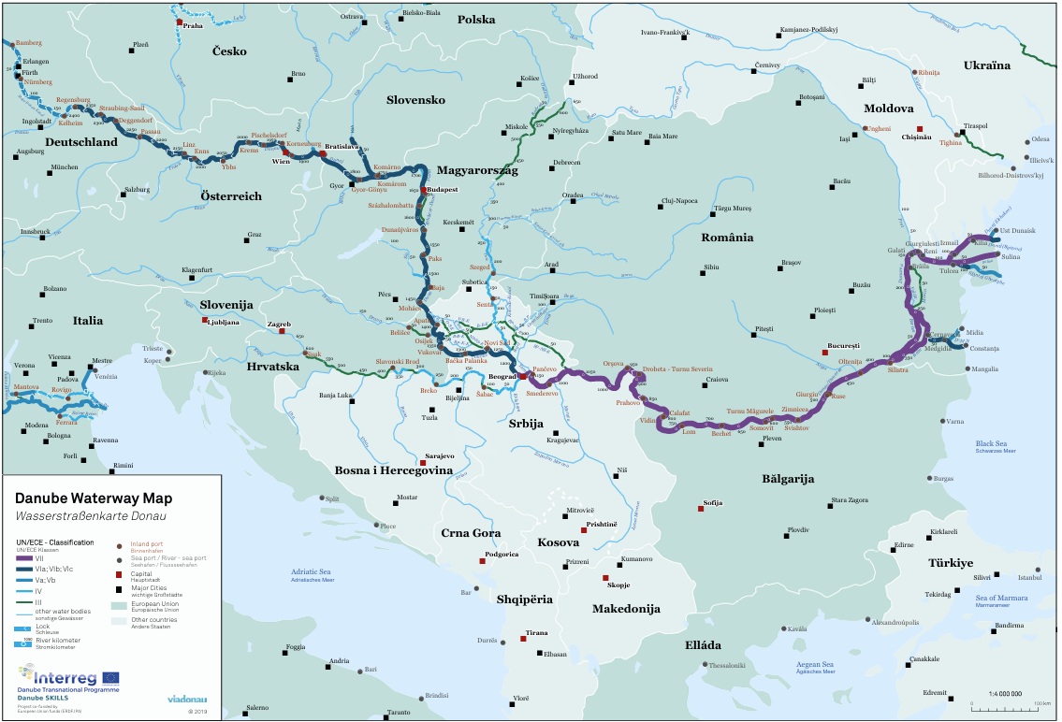
Image source: viadonau (https://www.viadonau.org/newsroom/publikationen/wasserstrassenkarten)

