Activity booklet
Sustainably from A to B

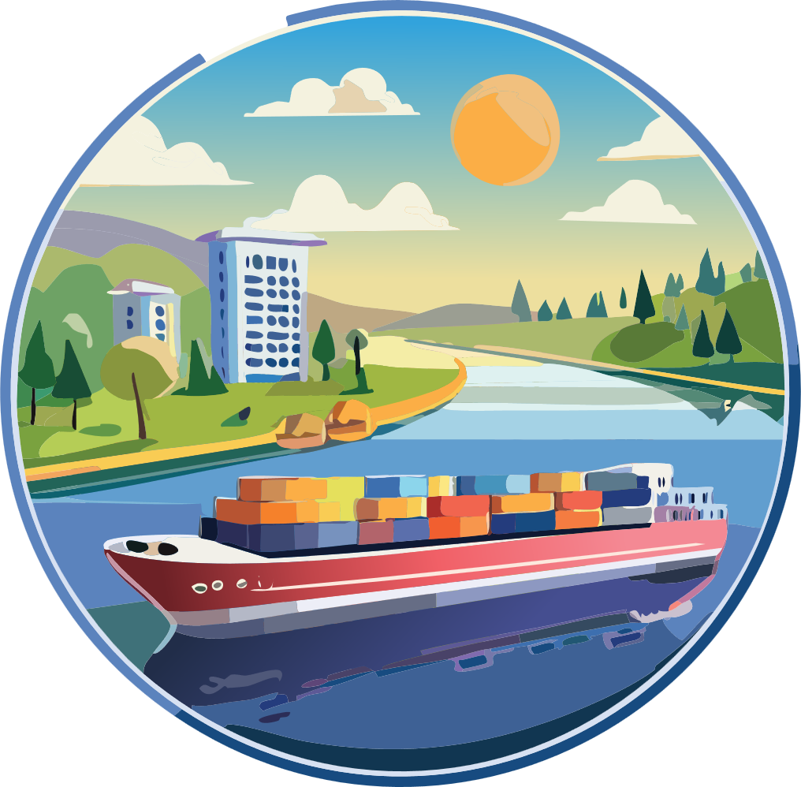
Dive into the world of mobility
and discover how goods can be transported in an environmentally friendly way!

Name:




What can be used to transport goods?
What do you think: how environmentally friendly or harmful are these means of transport? Draw the appropriate face for each one.

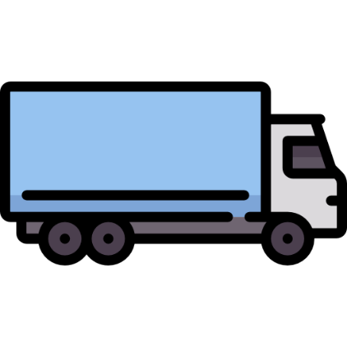

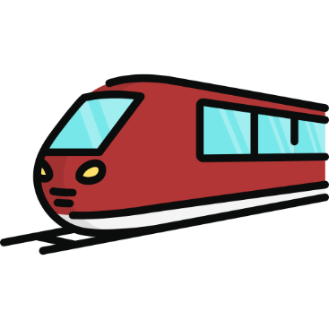




Fill-in-the-blank text

Fill in the gaps with the correct terms:

The of goods is important so that we can be supplied with food, clothing, and everything we need in our daily lives. Many goods are transported by . However, this travels on the road and causes a lot of and .
A better option is transport by . Rail transport is quieter and than truck transport.
Transport by on rivers is also a good idea. Ships can transport very and require less fuel than trucks. Transport on water is therefore better for the .
If we use more trains and ships, we can make an important contribution to .

Terms:
Noise | Train
Transport | Climate protection
More environmentally friendly | A lot
Truck | Nature
Inland vessel | Exhaust gases

Interview

Ask an adult which sustainable means of transport they prefer to use and why. Write down their answers.

I am a transport expert!
Cross out the incorrect answers.

Which means of transport causes the most emissions?
Train🚆 Airplane✈️ Bicycle🚲

An inland vessel is…
… a ship that only sails on the sea.
… a very fast boat for sports.
… a ship that travels on rivers and canals.

Which of these means of transport is the most environmentally friendly?
Truck🚛 Inland vessel🚢 Airplane✈️

What does “sustainable transport” mean?
- transport that is very fast
- transport that protects the environment
- transport that produces a lot of emissions

Which river is the most important waterway in Austria?
- Rhine - Danube - Inn

Why are regional products better for the environment?
Because they do not have to be transported far🚛
Because they look nicer🍏
Because long-distance transport produces more emissions🌍

Which means of transport can carry the most at once?
Truck🚛 Train🚆 Inland vessel🚢

Inland vessel “Danube Express”
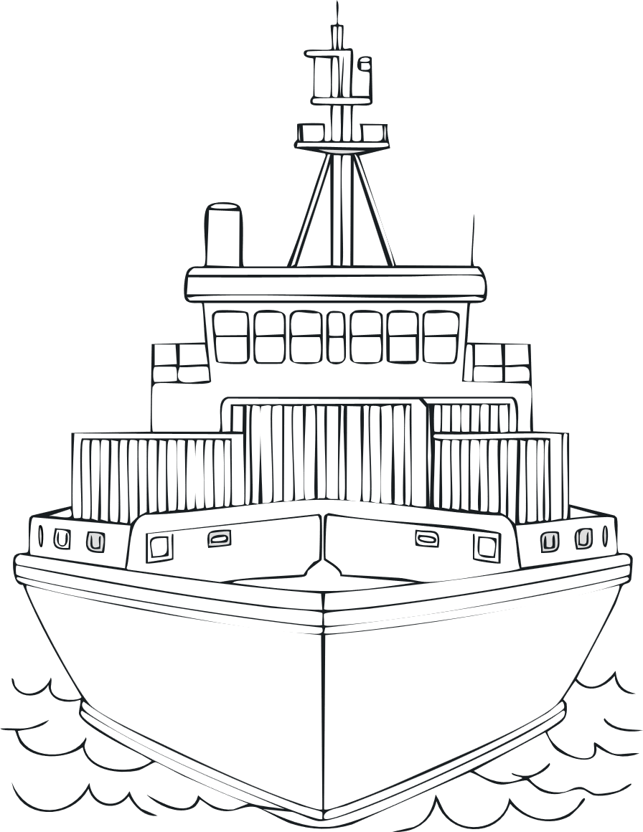
Read and color!

- Give the ship the name “Danube Express”.
- The sun is shining in the sky.
- The ship’s hull is blue.
- There is a red-white-red flag on the ship.
- A fish is swimming in the water.
- One container on the ship is green, another is yellow.

Your city, your ideas:

This is how transport becomes more sustainable!

Imagine you are the mayor of your city or community. You want more people to use public transport and fewer people to drive cars.
What would you do? Write a short plan with ideas on how you can help people travel more sustainably.

Transport idea of the future

Draw a means of transport that will be sustainable and environmentally friendly in the future.
Think about the following points before you start:
- What does my transport idea look like?
- Why is my transport idea so environmentally friendly?
- How and by whom is the means of transport controlled?
- What can be transported with it?
- What other special features does my idea have?

Image sources:

Flaticon (2024): https://www.flaticon.com/de/kostenlose-icons/lkw ; Truck icons created by Freepik – Flaticon, accessed 20.05.2024
Flaticon (2025): https://www.flaticon.com/de/kostenlose-icons/zug ; Train icons created by Mihimihi – Flaticon, accessed 06.02.2025
Flaticon (2024): https://www.flaticon.com/de/kostenlose-icons/schiff ; Ship icons created by Freepik – Flaticon, accessed 29.04.2024
Flaticon (2025): https://www.flaticon.com/de/kostenlose-icons/flugzeug ; Airplane icons created by Freepik – Flaticon, accessed 14.02.2025
Flaticon (2025): https://www.flaticon.com/de/kostenlose-icons/lastenfahrrad ; Cargo bike icons created by Freepik – Flaticon, accessed 14.02.2025
Flaticon (2025): https://www.flaticon.com/free-icons/electric-truck ; Electric truck icons created by Freepik – Flaticon, accessed 08.04.2025
Title image and inland vessel “Danube Express”: AI-generated with Adobe Illustrator

This activity booklet is available under a so-called Creative Commons Attribution 4.0 International license.
You are therefore free to integrate these exercises into your teaching, adapt them to your needs, and share them with your students.
We only ask that you leave the logos on the cover page unchanged.

If you have any questions or feedback, please feel free to contact us by email at rewway@fh-steyr.at .



