Film: Inland water vessel as environmental friendly transport alternative

The video "The inland vessel as an environmental friendly transport alternative" (online at https://youtu.be/PtRP9LWogI0) illustrates interesting facts and figures about inland navigation and the Danube waterway. The following short exercises deal with the contents of the video.
- Check whether the following statements are true (T) or false (F)
1. | Trucks cause the highest CO2 emissions of all land transport modes. | T | F
2. | An inland vessel can only transport small quantities of goods. | T | F
3. | Inland navigation is the most environmentally friendly means of transport in Europe. | T | F
4. | The capacity utilisation of an inland navigation vessel depends on the fairway conditions. | T | F
5. | Overall, the transport of ores, mineral raw materials, agricultural and forestry products, foodstuffs and petroleum products accounts for 75% of the total transport volume on the Austrian Danube. | T | F

- Assign the correct statements to the diagrams The percentages shown in blue correspond to the X% you are looking for.
X% of all European transports are carried out by truck.
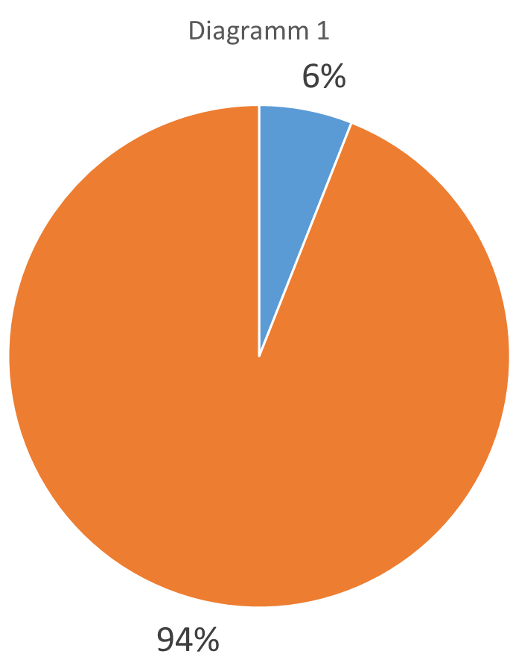
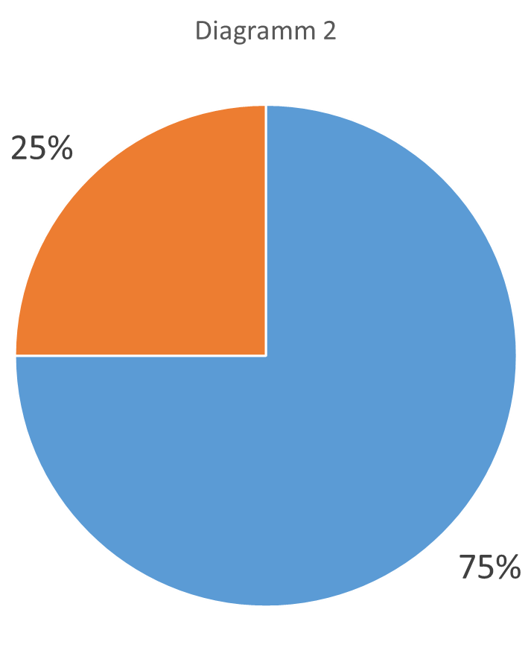
The capacity utilisation rate of the Danube is X%
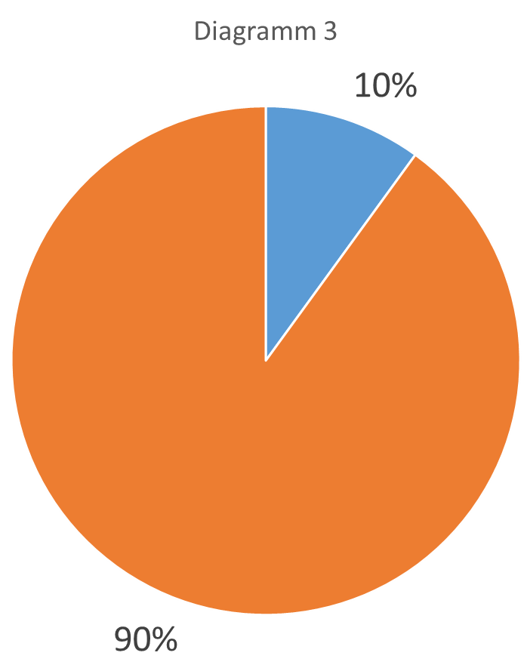
The inland vessel only has a share of X% of the freight traffic volume in Europe.

- Decide which of the following goods are suitable for transport by barge and which are not Mark them accordingly with a or a .

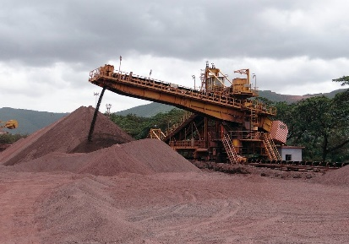
Iron ore Cut flowers

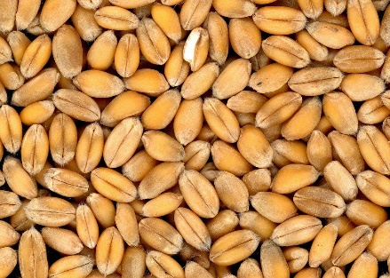
Bulk good e.g. grain Consumer electronics

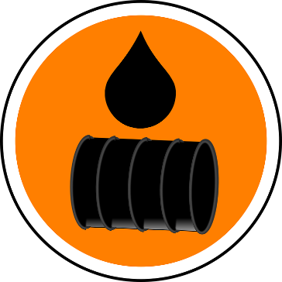
Time-critical Products Petroleum Products

Source of all pictures: pixabay

